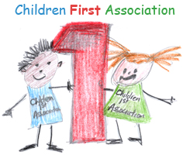

Children First Lunch Menu
Week commencing 14th November 2016

Monday
Fresh green salad with olive oil and lemon dressing | Organic meat tortellini pasta in a herb and butter sauce served with green peas | Beef  (CH)
Tuesday
Corn salad | Cheese tomato pizza with broccoli florets | Veg
Wednesday
Crunchy carrot sticks | Cheese cutlets served with wholewheat pasta and mixed vegetables | Veg
Thursday
Clear Spring soup | Chicken with Ebly and mixed fried sweet bell peppers, served with sour cream on the side | Meat (Brazil)
Friday
Cucumber salad | Spaghetti with peperoni sauce and organic fresh green beans | Veg

